

### **A Practical Implementation Guide for Symmetric Key**

### **Management**

**“Ensuring Data Security with Efficient Key Management Practices”**

Documentation by: [www.linkedin.com/in/aqsa-fareed-0b7162293](http://www.linkedin.com/in/aqsa-fareed-0b7162293)

## **Table of Contents:**

1. Introduction
2. Overview of Symmetric Key Management
3. Key Management Best Practices
4. Project Description
5. Detailed Report
6. Conclusion
7. Additional Resources
8. Contact Information

### **1. Introduction**

In the era of digital data, safeguarding sensitive information is paramount. SecureSym provides a comprehensive solution for managing symmetric keys efficiently to ensure data security. This documentation offers practical implementation guidance to streamline key management practices and enhance data protection.

### **2. Overview of Symmetric Key Management**

Symmetric key cryptography forms the backbone of data encryption systems. Effective management of symmetric keys is essential for securing sensitive data against unauthorized access and cyber threats. SecureSym offers a robust framework for generating, verifying, and managing symmetric keys securely.

### **3. Key Management Best Practices**

SecureSym adheres to industry best practices and standards for symmetric key management. This section outlines key management best practices, including key generation, authentication, revocation, and administrative functionalities, to maintain the integrity and confidentiality of encrypted data.

### **4. Project Description**

The provided C++ program is a Symmetric Key Management System designed to generate, verify, and manage symmetric keys. It includes features for user authentication, key revocation, and limited administrative functionalities.

The system operates in the following manner:

* **User Authentication:** Users are required to provide their username and password to access the system.
* **Key Generation:** Upon successful authentication, users can specify the desired key length in bits. A symmetric key is then generated using a secure random number generator.
* **Key Verification:** The generated key is encrypted using an encryption key and then decrypted to verify its correctness. If the decryption matches the original key, verification is successful.
* **Key Management:** The system maintains a record of generated keys, including their expiry dates and status (revoked or used). Users with specific privileges can perform administrative tasks such as adding or removing users, viewing key details, and revoking keys.
* **User Interaction:** The system interacts with users through a command-line interface, prompting for input and providing feedback accordingly.

### **Detailed Report:**

### **1. Including Libraries:**

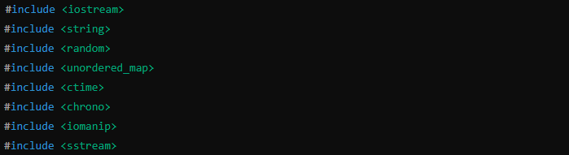

* **Explanation**: These lines include necessary C++ standard libraries:
* **<iostream>**: Input/output operations.
* **<string>**: String manipulation.
* **<random>**: Random number generation.
* **<unordered_map>**: Unordered map container for storing key-value pairs.
* **<ctime>**: Functions for manipulating date and time.
* **<chrono>**: Utility functions for time measurement.
* **<iomanip>**: Input/output manipulators.
* **<sstream>**: String stream processing.

### **2. SymmetricKeyManager Class:**

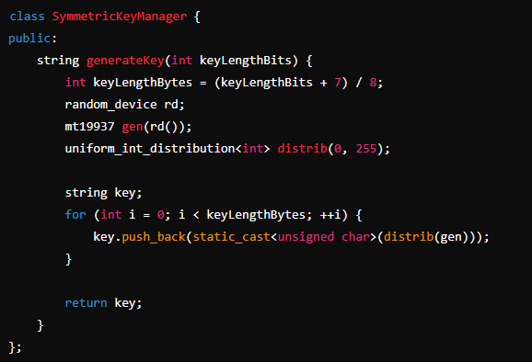

* **Explanation**: Defines a class **SymmetricKeyManager** responsible for generating symmetric keys.
* **generateKey(int keyLengthBits)**: Method to generate a symmetric key of a specified length in bits.

### **3. KeyInfo Struct:**

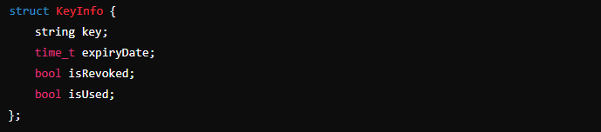

* **Explanation**: Defines a struct **KeyInfo** to hold information about a symmetric key, including the key itself, expiry date, and status (revoked or used).

### **4. KeyManager Class:**

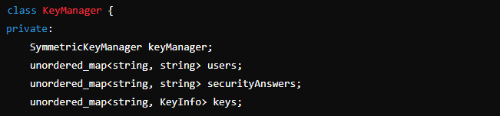

* **Explanation**: Defines a class **KeyManager** responsible for managing symmetric keys, user authentication, and key revocation.
* **keyManager**: Instance of **SymmetricKeyManager**.
* **users**: Unordered map to store username-password pairs.
* **keys**: Unordered map to store symmetric keys and their information.

### **5. Member Functions of KeyManager Class:**

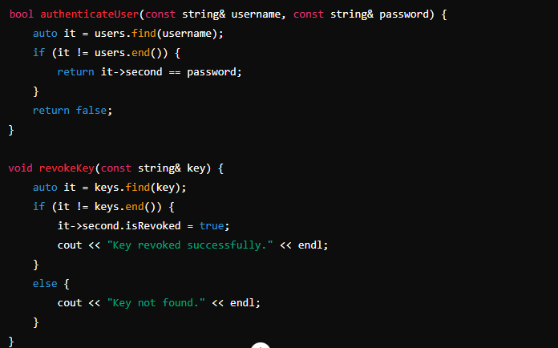

* **Explanation**: These member functions perform various operations within the **KeyManager** class.
* **authenticateUser(const string& username, const string& password)**: Authenticates user credentials against stored values.
* **revokeKey(const string& key)**: Revokes a symmetric key.

### **6. Private Member Functions of KeyManager Class:**

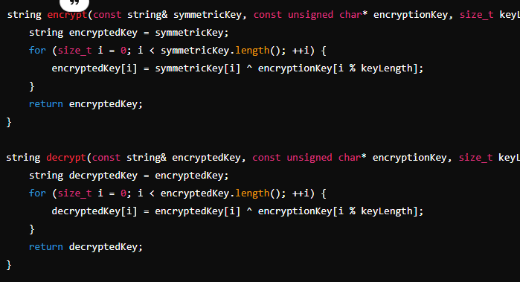**Explanation**: These functions are used for encryption and decryption.

* **encrypt(const string& symmetricKey, const unsigned char* encryptionKey, size_t keyLength)**: Encrypts the symmetric key.
* **decrypt(const string& encryptedKey, const unsigned char* encryptionKey, size_t keyLength)**: Decrypts the encrypted key.

### **7. Main Function:**

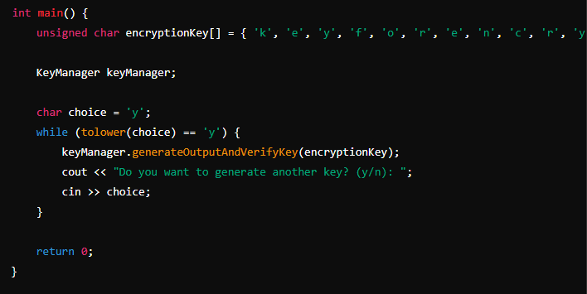**Explanation**: The **main()** function initializes the encryption key, creates an instance of **KeyManager**, and enters a loop for generating and verifying symmetric keys.

### **8. Key Generation and Verification Loop:**

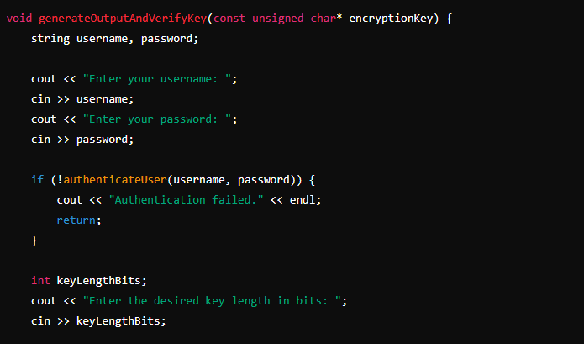

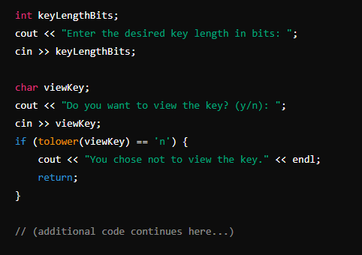

**Explanation**: This loop prompts users to generate and verify symmetric keys repeatedly until they choose to exit. It calls the **generateOutputAndVerifyKey()** function of the **KeyManager** class.

### **Conclusion:**

Each part of the code serves a specific purpose within the Symmetric Key Management System. From generating symmetric keys to managing user authentication and revocation, the code is structured to ensure security and functionality. Further development could focus on enhancing error handling, input validation, and security measures to make the system more robust and secure.

**Contact information:-**

Nimra Shahid  
Email: nimrashahidktk3@gmail.com  
Linkdln: [www.linkedin.com/in/nimra-shahid-cyber](http://www.linkedin.com/in/nimra-shahid-cyber)